Illinois Works Pre-apprenticeship Program Information Sheet
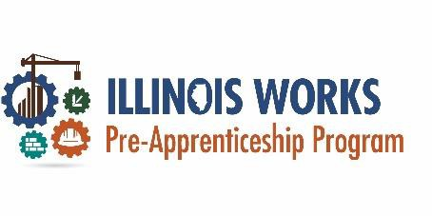



Program Design & Goal
The Illinois Works Pre-Apprenticeship program is designed to increase the number of qualified construction and building trades apprentices who are women, people of color, veterans, and prepare them to enter full apprenticeship programs on their way to careers in the construction and building trades. Program is background friendly!

Eligibility Requirements
To enter the program applicants must be/have:

18 years old Illinois resident
High school diploma or GED
Interest in and able to retain a career in the construction & building trades

Additional Criteria
The following criteria are not requirements but will help participants be more successful in the program. If applicants need assistance with any of the following, the program can offer these services:

Job Readiness & Registered Apprenticeship Assistance
Resume Writing
Mock Interviews
Pre-Apprenticeship Application Assistance
Driver’s License Fees Assistance Transportation Assistance Financial Literacy
Housing Referrals and more!

Stipends
Stipends are paid out based on participant performance including attending mandatory sessions and passing module assessments.

Industry Recognized Certifications/Credentials:
NCCER Core Curriculum Certification
OSHA 10-Hour Construction Certification First Aid/CPR Certification

Module | Required Hours
Illinois Works Pre-apprenticeship Orientation | 4
Introduction to Construction & Trades | 1
OSHA 10 Certification | 10
First Aid/CPR/AED | 4
Basic Safety | 13
Introduction to Construction Math | 10
Supplemental Math Construction | 30
Introduction to Hand  Tools | 10
Introduction to Power Tools | 10
Introduction to Construction Drawings | 10
Basic Communication Skills | 8
Employability Skills | 32
Workplace Harassment Prevention & Workplace Diversity & Inclusion | 8
Introduction to Material Handling | 5
Test taking skills | 4
Work-based Learning/Worksite | 40
Total Hours | 199

For more information about our FREE 10 week training, contact:

Community Assistance Programs
CAPs Roseland - 11717 South Halsted Street


Or
CAPs Chatham 200 East 75th Street

773-568-1782
www.capsinc.org
askus@capsinc.org

